GALATIANS BIBLE STUDY WESTVIEW BAPTIST CHURCH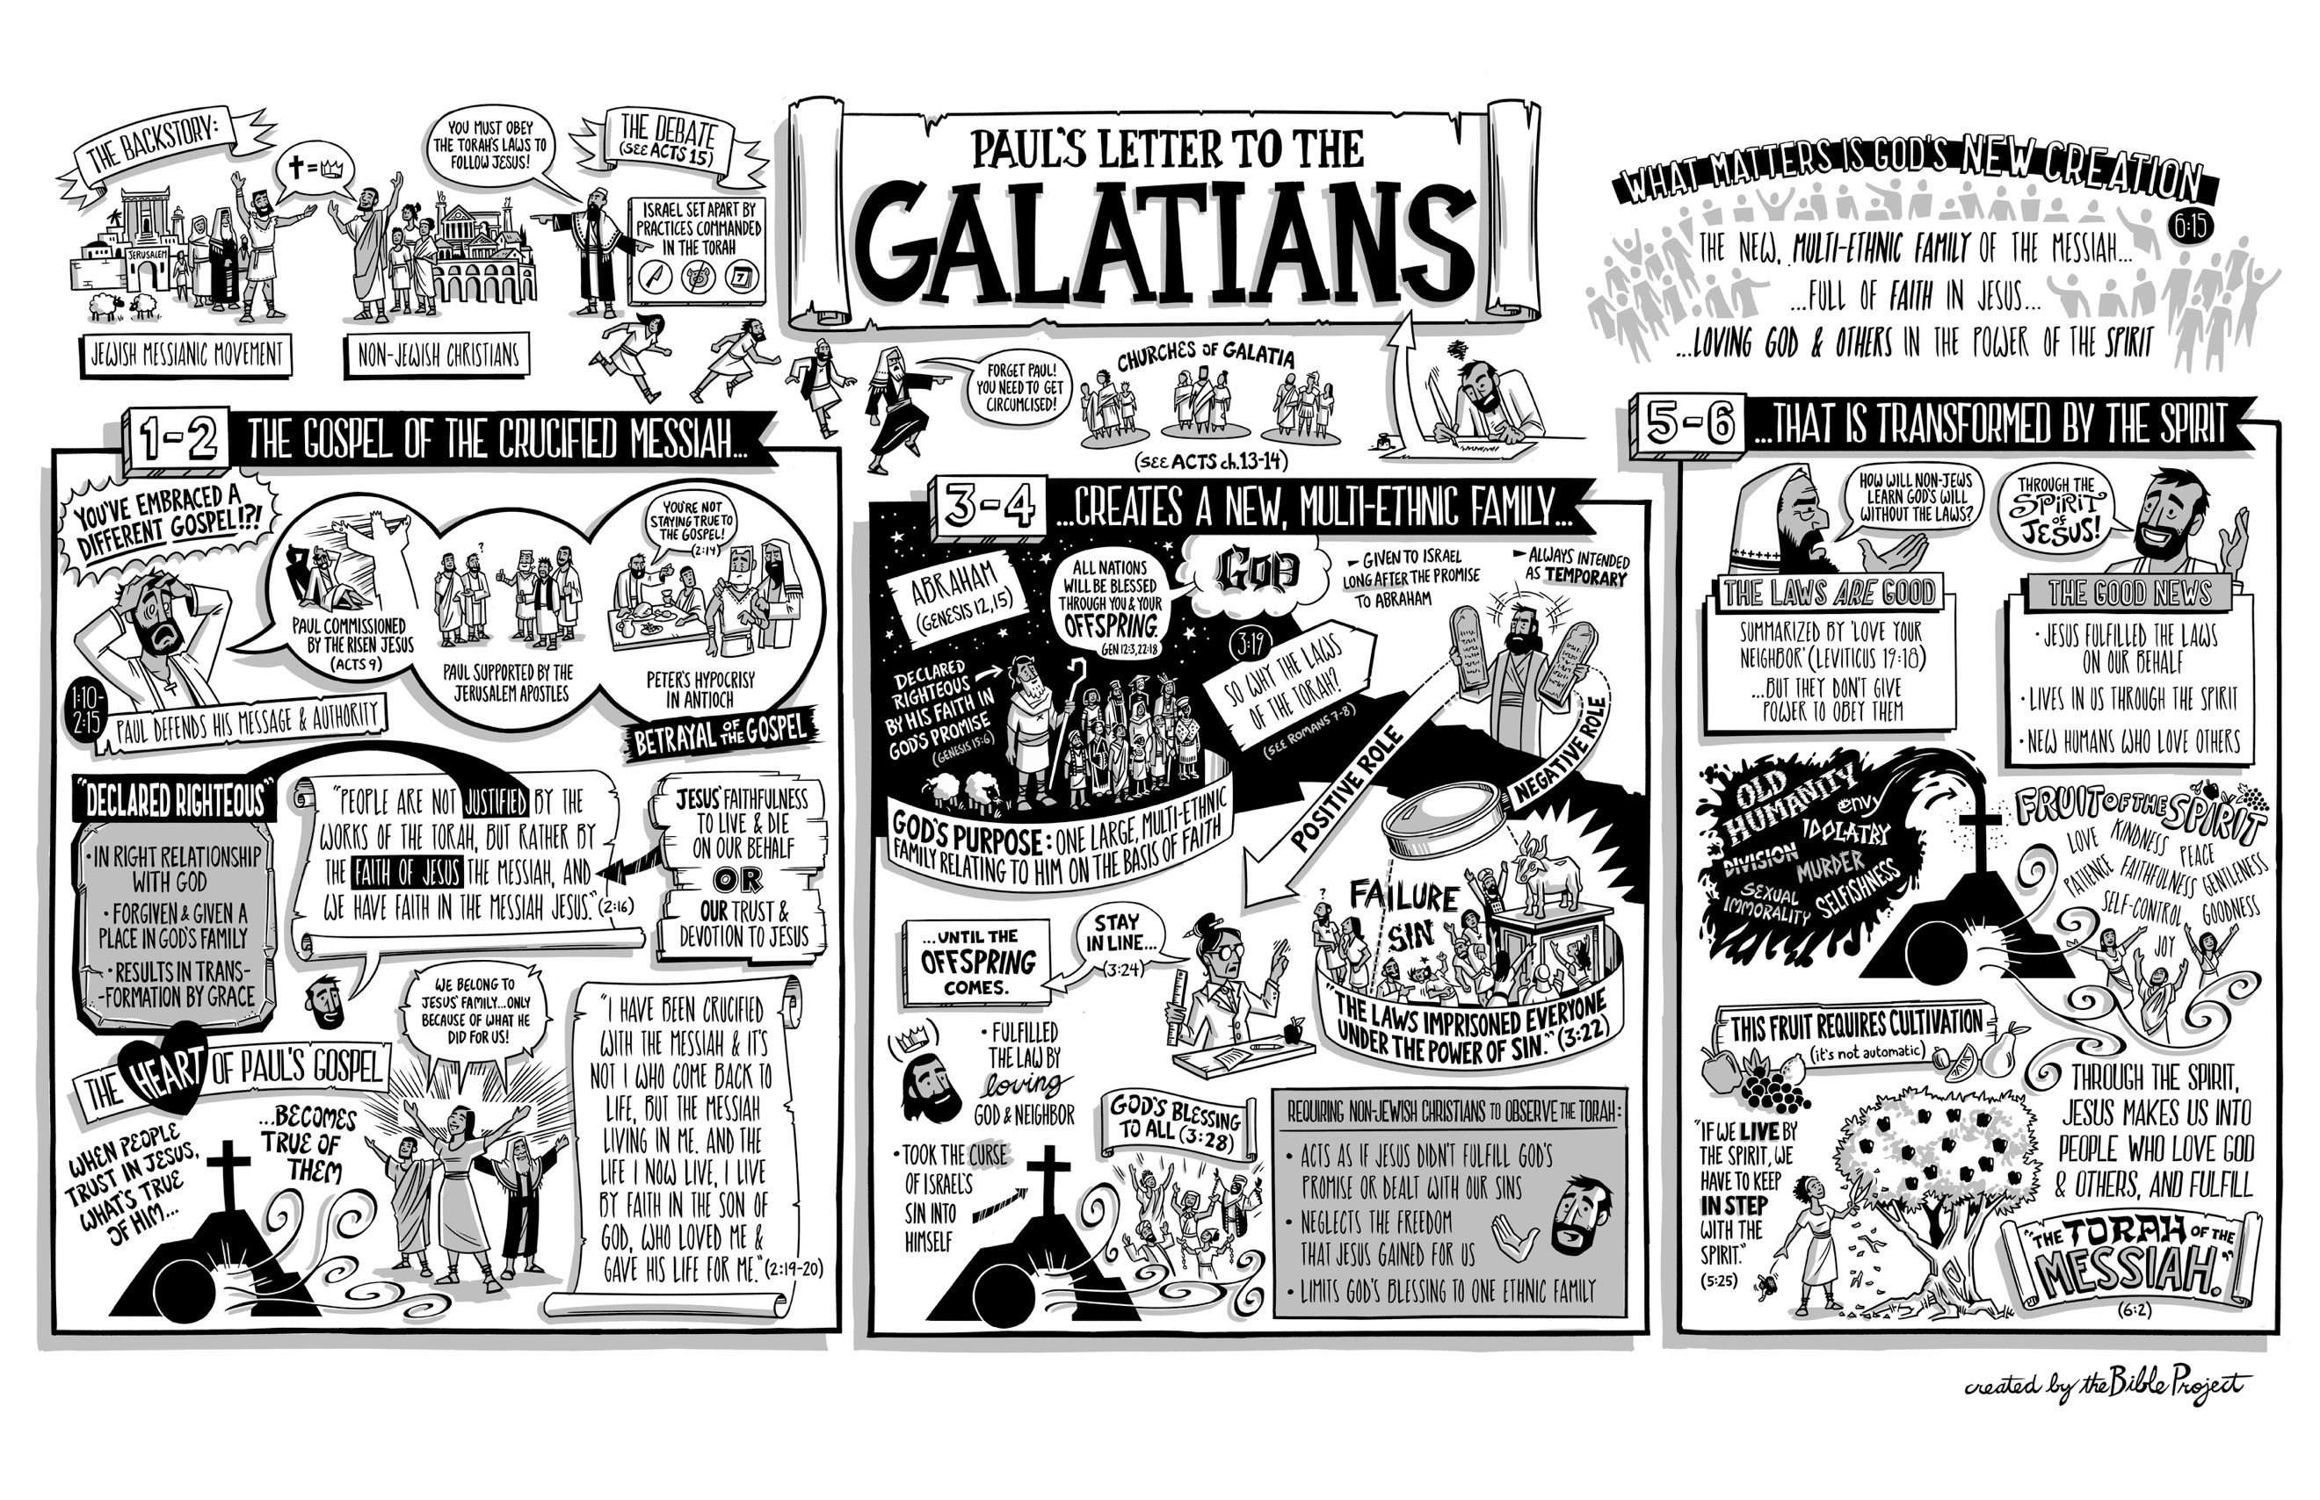For the next six weeks we are going to spend time together as a church on Sunday mornings walking through the book of Galatians.
In addition to that, we have created a daily (Mon. to Fri.) Scripture reading and study guide to help you go even deeper and to create a rhythm of reflection over this time.
Each day you will be given a small passage of Scripture and two (sometimes three) questions. This is meant to be a catalyst to help spur you into greater study during your quiet time.
As a pastoral team we recognize that in as much as we can’t be together as a church we can still grow together in our faith. We hope this study does just that.
To get a great overview of Galatians we invite you to watch this quick video: https://www.youtube.com/watch?v=vmx4UjRFp0M
Blessings,
Westview Pastoral Team
Galatians 1:1-10 WEEK ONE
April 13
Read Gal.1:1-2 & Acts 9:3-19
Q: How was Paul made an apostle?
Q: Who does God say you are? What title do you need to take to heart?
April 14
Read Gal.1:1-5 & Romans 5:1-5
Q: Where does grace & peace come from?
Q: Where are you currently seeking grace & peace from? If it isn’t form God…why?

April 15
Read Gal.1:3-5 & Isaiah 53:4-6
Q: Why did Christ give Himself “for our sins?”
Q: Are there still sins that you feel condemned by? Confess them to Christ, and experience freedom today.

April 16
Read Gal.1:6-9
Q: Are you running to or running from the calling God has placed on your life?
Q: Why do people so quickly turn away from the gospel? Where have you turned away from the gospel?

April 17
Read Gal.1:6-10 & 2nd Corinthians 5:11-15
Q: Is there anything that truly satisfies and sustains our lives other than the gospel?
Q: Why does Paul take the abandonment of following the gospel so seriously? Do you take the gospel this seriously?
Galatians 1:11-2:21 WEEK TWO
April 20
Read Gal. 1:11-14
Q: How did Paul receive the gospel? Why is this significant?
Q: Why was it so important for Paul to make sure the Galatians knew about his former way o life before coming to know Christ as Saviour?
April 21
Read Gal. 1:15-17
Q: How did God call Paul? How does he call us?
Q: What is God calling you to do? How are you to share the gospel?
April 22
Read Gal. 1:18-24
Q: What had the people in Syria & Cilicia heard about Paul?
Q: What did other Christians think when they heard that Paul was preaching the gospel?
April 23
Read Gal. 2:1-10
Q: What type of freedom do we have in Christ?
Q: Explain the phrase “God shows no favouritism between people (vs.6)
Q: Why would “remembering the poor” be the one thing Paul & Barnabas were asked to do?
April 24
Read Gal. 2:11-21
Q: Why is Paul so strong in his rebuke of Peter and his hypocrisy?
Q: What does hypocrisy do to you and I in our ability to demonstrate Christ to others?
Q: What does it look like for Christ to live in us? How ought that to impact your life every day?
Galatians 3:1-25 WEEK THREE
April 27
Read Gal. 3:1-7
Q: How do we receive the Holy Spirit? By works? Faith? Why is this so important to Paul?
Q: Who are the true children of Abraham today (cf. Gal. 3:26-27)

April 28
Read Gal. 3:8-14
Q: Why is it impossible for humankind to be justified by the law?
Q: How did Christ “become a curse for us?”

April 29
Read Gal. 3:15-18
Q: How did God confirm His covenant?
Q: Why did God give the Mosaic Law?

April 30
Read Gal. 3:19-22
Q: Why was the law given? What was its purpose?
Q: Does Galatians 3:19 tell us when the Law would end? If so, how?

May 1
Read Gal. 3:23-25
Q: Are we still under the law? What are the implications of your answer for your daily life?
Q: How are we justified by faith?
Galatians 3:26 -4:31 WEEK FOUR
May 4
Read Gal. 3:26-29
Q: What does it mean to be God’s children?
Q: What are Christians heirs to?

May 5
Read Gal. 4:1-7
Q: Given what Galatians 4:4 says, why did Christ come into the world when He did instead of in our day & age?
Q: How was Paul adopted? How does the biblical image of adoption impact your understanding of what it means to a part of the family of God?

May 6
Read Gal. 4:8-11
Q: Why did the Galatians turn so quickly back to weak and miserable forces?
Q: Why do we oftentimes turn back to the sins of our past (and future) to satisfy us as “gods” instead of turning towards God?

May 7
Read Gal. 4:12-20
Q: Why does Paul beg the Galatians to become like him? What do you think he means?
Q How did the Galatians treat Paul? Could this serve as a model for how we ought to treat others?

May 8
Read Gal. 4:20-31
Q: Paul is anchoring this part of the text in key parts of the OT. Galatians 4:27 is a quote from where then in the Old Testament?
Q: Who are we children of?

Galatians 5:1-26 WEEK FIVE
May 11
Read Gal. 5:1-5
Q: Galatians 5:1 says that Christ has made us free. Free from what?
Q: What is the “hope of righteousness?

May 12
Read Gal. 5:6-10
Q: Why is faith working through love so important to Paul? How can you demonstrate faith through love today? This week?
Q: Who or what sometimes stops you from running a good race? What can you do to ensure this doesn’t happen again?
May 13
Read Gal. 5:11-15
Q: Paul implores the Galatians to not use their freedom to indulge “in the flesh”. How could one use their “freedom” to indulge in the flesh?
Q: How could Christians be “consumed by one another”?

May 14
Read Gal. 5:16-21
Q: What does it mean to “live by the Spirit”?
Q: Galatians 5:19-21 lists many sins, are any of them—in your opinion—often minimized or overlooked? Why?

May 15
Read Gal. 5:22-26
Q: How can you tell if someone has the “fruit of the Spirit” in their life?
Q: Which of the fruits listed is one that you desire to grow in? What steps can you take in order to see this come to fruition?
Galatians 6:1-18 WEEK SIX
May 18
Read Gal. 6:1-3
Q: Why does Paul make sure to emphasize that we are to restore a brother or sister who has sinned with a spirit of gentleness?
Q: What are to do with the burdens of others?

May 19
Read Gal. 6:4-6
Q: Have you fallen into the trap of comparison? Who are you comparing yourself to?
Q: Instead, who should you be modeling your life after? What difference would this make in our life?

May 20
Read Gal. 6:7-10
Q: What would keep us from growing “wearing in doing good?”
Q: What “good” in the name of Jesus could you do today? This week? This month? How might this be a blessing to that person? Group? Etc…

May 21
Read Gal. 6:11-14
Q: Why is Paul so adamant that it is less important to focus on the “external” signs of faith (eg: circumcision) instead of focussing on the condition of our heart?
Q: Why, for Paul, is it so important to boast in the cross?

May 22
Read Gal 6:15-18
Q: What does Paul mean by a “new creation”? Where else do you find this imagery in the Bible?
Q: What is promised to those who behave according to/follow this rule?

