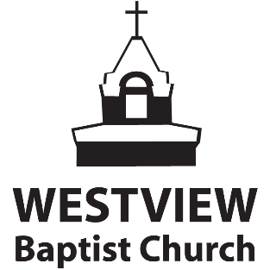
Easter Sunday April 12 // Online Worship Service

WORSHIP*:
* to watch the YouTube videos simply click the song title.
King Of Kings - Hillsong Worship
Welcome to our Easter worship service. Although we cannot be together in one place as a congregation, we can each bring the same elements of worship as we praise our God. I invite you to follow this outline as together we remember His sacrifice for us.
PRAYER: Father, thank you for your presence with us as we come to worship you. We pray that you would prepare our hearts so that our praise will be pleasing to you. Forgive us our sin and fill us with your Holy Spirit that we might praise you and bring you glory. Amen.
-------------------------------------------------------------------------------------------------------------------------------------------------
GIVING:
We are aware that during this time there are many financial needs as a church family. We also know that giving is an integral part of worship and something we want to encourage you all to stay active in doing. We have made it simple to be able to still give through Push Pay (our electronic giving platform.) You can give on our website, or through the PushPay app. You may also give by using eTransfer; (instructions are on our website.) You may also mail a cheque to the church, but please do not bring cash to the building.
Let’s pray:
“Father, we are aware that there is a lot of uncertainty in our world right now, but we recognize in this time you still call us to a life of worship, to a life of trust and obedience. We pray that during this time our worship will continue through giving, knowing that the work of ministry is not done. Use the generosity of your people to fuel the advance of the gospel so that more will come to know Jesus as Lord & Saviour.
CLICK HERE TO GIVE
WORSHIP
Read : John 1:4-5 & Titus 2: 11-14
Hope Of The Nations – Unknown
This I Believe – Hillsong
Glorious Day – Kristian Stanfill
-------------------------------------------------------------------------------------------------------------------------------------------------
MESSAGE – Easter Sunday (Gal. 1:1-10)
CLICK HERE TO WATCH/LISTEN
SUNDAY SCHOOL
YOUTH MINISTRY
To access the Youth Lesson please visit the April 12 sermon page
CHILDREN'S MINSITRY
To access the Children’s Lesson please visit the April 12 sermon page
-------------------------------------------------------------------------------------------------------------------------------------------------
Closing Songs
Because He Lives (original) – Unknown
Because He Lives (Amen) – Matt Maher
------------------------------------------------------------------------------------------------------------------------------------------------
Thank you for worshipping with us this morning. He is Risen! Happy Easter.

